**DAILY ONLINE ACTIVITIES SUMMARY**

|  |  |  |  |  |  |  |  |  |
| --- | --- | --- | --- | --- | --- | --- | --- | --- |
| **Date:** | **23/05/2020** | | | | | **Name:** | **V ANJANA PAI** | |
| **Sem & Sec** | **IV sem & B section** | | | | | **USN:** | **4AL18CS094** | |
| **Online Test Summary** | | | | | | | | |
| **Subject** | | **DATA COMMUNICATION** | | | | | | |
| **Max. Marks** | | **30** | | **Score** | | | **26** | |
| **Certification Course Summary** | | | | | | | | |
| **Course** | **Python for Machine Learning** | | | | | | | |
| **Certificate Provider** | | | **Great learning academy** | | **Duration** | | | **5.0 hour** |
| **Coding Challenges** | | | | | | | | |
| **Problem Statement:** Write a C Program to generate first N Triangular Numbers (Where N is Read from the Key board) | | | | | | | | |
| **Status: Executed** | | | | | | | | |
| **Uploaded the report in GitHub** | | | | | **YES** | | | |
| **If yes Repository name** | | | | | **lockdown-coding** | | | |
| **Uploaded the report in slack** | | | | | **YES** | | | |

Online Test Summary: 18CS46 test was scheduled from 9:15 am t0 9:55am. The portion for the IA was 1st module and 2nd module there were 30 questions and the time assigned was 40 minutes the questions were mcq type.

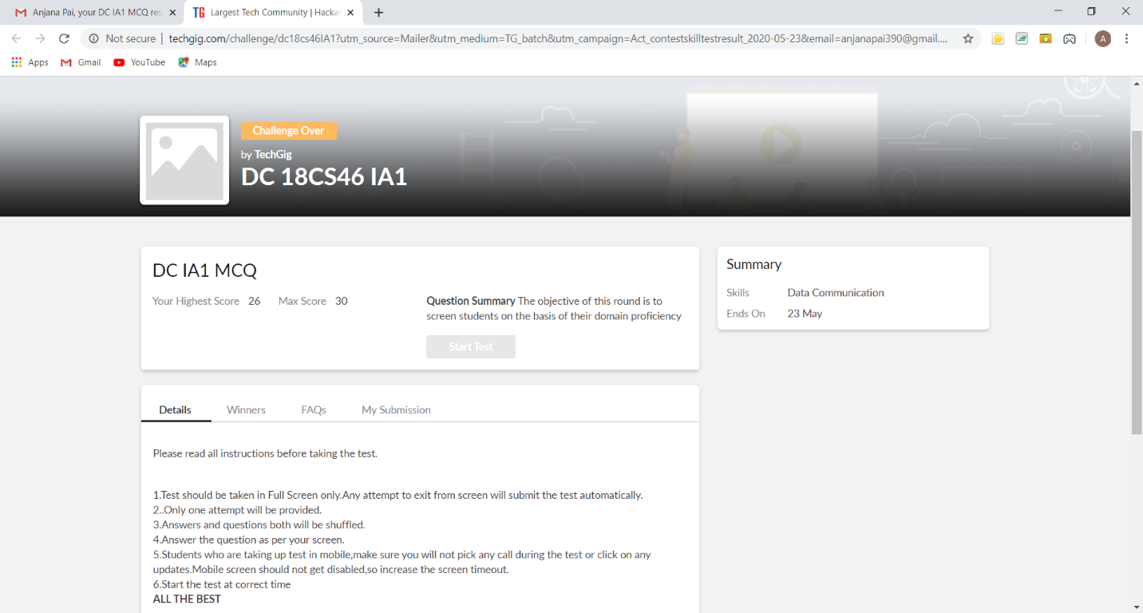

The above snap shot is the completion of the test and the marks allotted.

Online Certification Course Summary: Today I continued with the course on the topic NumPy introduction. Where I learnt about NumPy which is the fundamental package for scientific computing with Python. And also learnt about indexing using NumPy which can be done by using an array as an index. NumPy arrays can be indexed with other arrays or any other sequence with the exception of tuples.

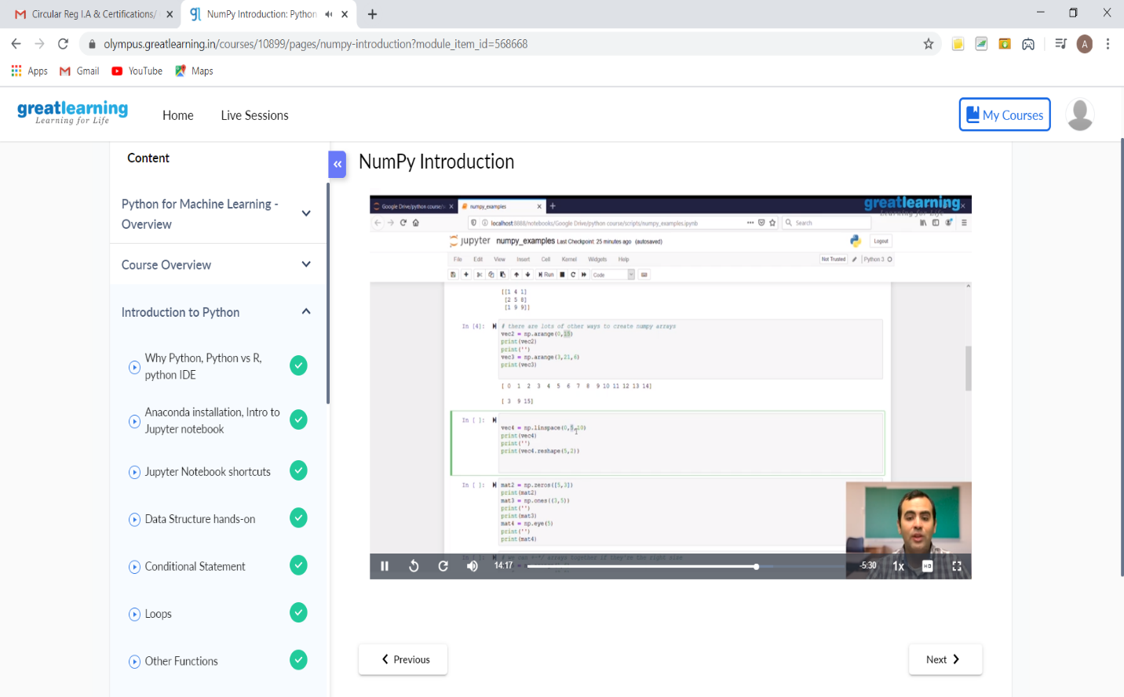

This is the snap shots of today’s session.

Online Coding Summary: **Today I had received one program from prof. Venkatesh CSE Dept. The programs are mentioned above in the coding challenges(pg.01). I have also uploaded it to my GitHub repository.**

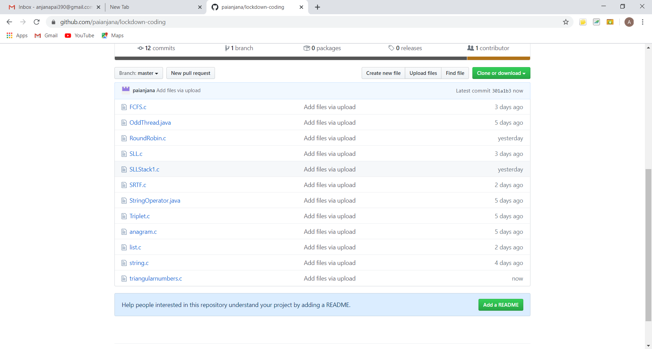

It is the snap shot of my repository where I have uploaded the code. File name is triangularnumbers.c